**CHAPTER 1**

**INTRODUCTION**

**1.1 INTRODUCTION**

In today’s fast-paced digital world, automation and online systems are playing a vital role in transforming traditional financial processes. One such process is loan management, which is an essential service in the banking and financial sector. Traditionally, managing loan applications involved manual paperwork, in-person visits, and long processing times, often resulting in delays and inefficiencies.

The loan management system is a web-based solution designed to automate and simplify the entire process of applying for, processing, and managing loans. This system enables both users (loan applicants) and administrators (bank officials or financial agents) to interact on a common platform, thereby reducing the gap between service providers and consumers.

The system allows applicants to register, log in, apply for loans, track the status of their applications, and calculate EMIs based on input parameters such as loan amount, interest rate, and duration. On the other hand, administrators can review all loan applications, approve or reject them, and manage user data through a secure dashboard. This improves the overall efficiency and transparency of the loan approval process.The goal of this project is to provide a reliable, user-friendly, and secure application that handles the entire loan lifecycle, from application to approval, in a seamless and systematic manner.

This system is particularly beneficial for small to medium financial institutions or educational loan providers who want to digitize their services without investing in complex infrastructure. It reduces manual workload, speeds up processing time, and minimizes human error. With real-time updates and an organized database, the system ensures that users are always informed about their application status. The loan management system also includes additional features such as user profile management, editing user details, and an EMI calculator that helps applicants plan their finances before taking a loan. The admin panel allows full control over user registrations and loan approvals, making it easier for the organization to monitor and manage operations.

**1.2 OBJECTIVES**

The primary aim of this project is to develop an efficient and automated Loan Management System that simplifies the entire loan processing workflow. To achieve this, several specific objectives have been identified. These objectives focus on improving user experience, ensuring data security, enhancing transparency, and reducing manual effort for both loan applicants and administrators.

* To develop a web-based system that automates the loan application, approval, and management processes.
* To provide a simple and secure registration and login mechanism for loan applicants.
* To enable users to apply for various types of loans and track the status of their applications in real time.
* To incorporate an EMI calculator to help applicants estimate monthly installment amounts based on loan parameters.
* To design an efficient administrator dashboard for managing loan applications, approving or rejecting requests, and overseeing user accounts.
* To ensure data security and integrity through proper authentication and database constraints.
* To minimize paperwork and reduce manual errors by automating loan-related tasks.
* To enhance transparency and speed up the loan processing cycle for both applicants and administrators.
* To create a user-friendly interface that facilitates smooth interaction between users and the system.

**1.3 MODULES**

The Loan Management System is divided into several interconnected modules, each designed to perform a specific function that contributes to the overall system's operation. These modules work together to create a complete and functional web-based application for handling the loan process from registration to approval and repayment tracking.

**1. User Registration and Login Module**

This module allows new users to register on the platform by filling in required details such as username, password, and role (applicant or admin). The registration information is stored securely in the database. Once registered, users can log in using their credentials. The system validates the login details and redirects users to their respective dashboards based on their roles. This module ensures authentication and provides access control to prevent unauthorized usage.

**2. User Dashboard Module**

After successful login, applicants are taken to a personalized dashboard. The user dashboard acts as a control panel from where users can apply for loans, view their submitted applications, check approval status, use the EMI calculator, and manage their profiles. The dashboard provides a clear and simple interface to access all essential services in one place.

**3. Loan Application Module**

This module enables users to apply for a loan by submitting a form that includes information such as loan amount, interest rate, loan type, and repayment duration. The application is stored in the loans table in the database and marked as 'pending' by default. This module ensures that all necessary data is collected in a structured format, ready for admin review.

**4. Admin Login and Dashboard Module**

The admin has a separate login portal to access their dashboard. Once logged in, the admin dashboard provides various management tools, such as viewing a list of all users, seeing pending loan applications, and tracking payment details if implemented. The admin interface is built to offer complete control over the system while maintaining data security and system integrity.

**5. Loan Approval and Management Module**

This module is exclusively used by admins to review loan applications. Each application can be approved or rejected based on criteria such as amount, interest, and user details. Once the admin makes a decision, the status of the loan is updated in the database and instantly reflected in the applicant’s dashboard. This module helps automate the decision-making process and reduces manual follow-ups.

**6. EMI Calculator Module**

The EMI (Equated Monthly Instalment) Calculator is a useful tool provided to users before they apply for a loan. By entering the loan amount, interest rate, and loan duration (in months or years), users can estimate how much they will need to repay each month. This feature helps users make informed financial decisions and improves transparency in the loan process.

**7. Profile Management Module**

Users can view and edit their profile information such as username and password. This module ensures that personal data can be updated as needed and remains secure. It enhances user experience by allowing easy management of individual account details.

**CHAPTER 2**

**SURVEY OF TECHNOLOGIES**

**2.1 SOFTWARE DESCRIPTION**

The Loan Management System is developed as a web-based application using standard technologies for both the front end and back end. The system handles user registration, loan application, loan approval, and payment tracking.

**1. PHP (Hypertext Preprocessor)**

PHP is the server-side scripting language used to develop the core functionality of the system. All dynamic operations such as user authentication, loan submission, admin login, data insertion into the database, and retrieval of records are handled using PHP scripts. PHP processes the logic behind user interactions and acts as the link between the front end and the MySQL database.

**2. MySQL**

MySQL is the database management system used to store and manage all the data. The database contains multiple tables such as users, loans, and payments. Each table has a specific role:

* users table stores user credentials and roles (admin or applicant)
* loans table holds loan details like loan amount, interest rate, loan term, and status
* payments table stores payment-related information against loans

Relationships between tables are maintained using foreign keys to ensure data consistency.

**3. HTML (Hypertext Markup Language)**

HTML is used to design the structure of the web pages. It is used for creating forms for login, registration, loan application, and admin operations. Every visual element on the browser such as text fields, buttons, and tables is built using HTML.

**5. XAMPP**

XAMPP is used to run the application on a local server environment during development and testing. It provides Apache (the web server) and MySQL (the database server), which are required to host and execute PHP files and manage the database respectively.

**6. Google Chrome**

Google Chrome is used to open and test the web application interface. It allows the developer to check form functionality, validate inputs, navigate between pages, and view data fetched from the database. Chrome’s developer tools also assist in debugging layout and style issues.

**7. Visual Studio Code**

Visual Studio Code (VS Code) is the source code editor used to write the PHP, HTML code for this project. It supports syntax highlighting, code suggestions, and file management, making development easier and more organized.

**2.2 LANGUAGES**

In the development of the Loan Management System, several programming languages are used to ensure smooth functioning, interactivity, and data processing. The application is divided into two main parts: the Frontend (the user-facing side) and the Backend (the server-side processing and data management). Different languages and technologies are used in both parts, each playing a critical role in the system's overall operation.

**2.2.1 Frontend**

The frontend of the Loan Management System refers to the part of the application that is visible to users and allows them to interact with the system. It is responsible for collecting user input, displaying data, and providing navigation across different functionalities.

**HTML (Hypertext Markup Language):**  
HTML is used to define the structure and layout of web pages. It is used to create forms for user registration and login, loan applications, and administrative actions. HTML elements such as input fields, buttons, tables, and labels are used to organize the interface and collect user data effectively.

**Key frontend features :**

• Common Layout: All pages maintain a consistent structure with a header, content area, and styled background for visual uniformity.

• User Role Redirection: After login, users are redirected based on their role—admin users access the admin dashboard, while applicants access the user dashboard.

• Interactive Forms: Includes forms for login, registration, loan application, and payment tracking with clearly labeled fields and submission buttons.

• Feedback Messages: Displays alert messages for successful actions or errors (e.g., “Loan application submitted”, “Invalid credentials”).

• Tables: Loan and payment data are displayed in organized tabular formats for easy viewing and comparison.

**User Experience Design:**

• User Dashboard: Designed for simplicity, allowing applicants to apply for loans, view loan status, and check payment history.

• Admin Dashboard: Provides access to all user records, loan applications, and payment details with update or approval options.

• Visual Clarity: Uses neatly styled buttons, aligned input fields, and background color schemes to create a clean and user-friendly interface.

**2.2.2 Backend**

The backend is the core part of the Loan Management System, responsible for managing all operations that happen behind the scenes. It processes user inputs, applies business logic, interacts with the database, and ensures that the data flows correctly between the interface and the storage layer. In this project, the backend has been built using PHP and MySQL, and it runs in a local development environment provided by XAMPP.

**1.PHP (Hypertext-Preprocessor)**  
PHP is the server-side scripting language used for writing all the backend logic. It handles the dynamic functionality of the system by responding to user actions such as submitting forms, logging in, applying for a loan, and viewing or updating data. Some of the key roles PHP performs in this project include:

* User Authentication: Validates login credentials and redirects users based on their roles (admin or applicant).
* Loan Processing: Accepts loan application data from users, stores it in the database, and allows admins to view, approve, or reject these applications.
* Payment Management: Handles the logic for recording payments made by users towards their loans.
* Data Retrieval and Display: Fetches data from the database and displays it in HTML tables, such as lists of approved loans or payment histories.
* Session Handling: Maintains secure login sessions to prevent unauthorized access. Sessions are used to differentiate between users and admins throughout the application.

The PHP code is embedded into HTML pages using .php files, ensuring that backend processing and frontend display are tightly integrated.

**2.MySQL**  
MySQL is a relational database management system used to store all the application data in a structured format. The database used in this project consists of multiple interconnected tables:

* users table: Stores user credentials (username and password) and the user role (admin or applicant).
* loans table: Stores loan details such as loan amount, interest rate, loan term, loan status, and the user to whom the loan is assigned.
* payments table: Tracks payments made for specific loans, including the payment amount and date.

Foreign key constraints are implemented to maintain referential integrity between tables. For example, loan_id in the payments table is linked to the loans table, and user_id in the loans table is linked to the users table. These links ensure that data remains consistent and logically related.

**3.XAMPP**  
XAMPP is used as the development environment in this project. It provides an easy-to-use package that includes:

* Apache: The web server that hosts the PHP files and makes the application accessible via the browser at localhost.
* MySQL: The database server that stores all the application's data.
* phpMyAdmin: A graphical tool used to interact with the MySQL database, helping to run queries, manage tables, and monitor data without writing SQL manually.

XAMPP allows the entire project to be developed, tested, and run locally before deployment, ensuring a smooth development process.

**CHAPTER 3**

**REQUIREMENT AND ANALYSIS**

**3.1 REQUIREMENT SPECIFICATION**

The Loan Management System is designed to automate and optimize the handling of loan data, customer details, repayments, and application approvals. This system is crucial for banks or financial institutions that deal with multiple loan requests and need efficient management. These requirements define the core functionalities that the system must support to meet the needs of users and administrators.

**Functional Requirements**

Functional requirements describe the specific tasks the system must be able to perform to meet user needs.

**User Registration:**

New users (applicants) can create an account by providing a unique username and a password. This data is stored in the 'users' table in the database. Proper validations are applied to ensure all required fields are filled correctly.

**User Login and Authentication:**

The system verifies login credentials entered by users. Based on the credentials and the associated role (admin or applicant), users are redirected to their respective dashboards. Invalid login attempts are rejected with an error message.

**Role-Based Access Control:**

The system clearly separates admin functionalities from applicant functionalities. Applicants can only apply for loans and view their status, whereas admins can view all loan applications, approve or reject them, and monitor payments.

**Loan Application Submission:**

Applicants can apply for loans by filling out a form with details like loan amount, interest rate, loan term, and purpose. Upon submission, the data is saved into the 'loans' table with a default status of "pending.

**Loan Approval or Rejection:**

Admin users can view a list of all loan applications. They can then approve or reject each application based on predefined criteria. The loan status is updated in the database accordingly.

**Loan Status Viewing:**

Applicants can log in to view the current status of their loan applications (e.g., pending, approved, or rejected). This status is dynamically retrieved from the database.

**Payment Recording:**

Once a loan is approved, the applicant can make payments toward it. Payment details, including amount and date, are recorded and stored in the 'payments' table, linked to the respective loan ID.

**View Payment History:**

Applicants can view a history of all payments they have made for a specific loan. This helps in tracking the loan repayment progress.

**Admin Dashboard Features:**

Admins can view, search, and manage all users, loan records, and payment details. They can also update user data or delete records if necessary.

**Non-Functional Requirements**

Non-functional requirements define how the system behaves under specific conditions and what constraints exist.

**Usability:**

The system is designed with a user-friendly interface, making it easy for both admins and applicants to navigate, use forms, and access information without confusion.

**Performance:**

The application is expected to respond quickly to user actions such as login, form submission, and data retrieval, especially when hosted on a local server using XAMPP.

**Scalability:**

The database design supports the addition of more users, loans, and payments in the future without requiring major changes to the structure.\

**Reliability:**

The system ensures consistent performance. Validations are implemented to prevent incomplete or incorrect data entry.

**Data Integrity:**

Foreign key constraints are used in the database to maintain accurate relationships between users, loans, and payments, ensuring that no orphan records are created.

**Security:**

Passwords are securely stored (though in this version they are in plain text, which can be improved). Session handling prevents unauthorized access to dashboards.

**Portability:**

The system can run on any machine that has a compatible browser and a XAMPP environment installed, making it portable across multiple development or demonstration systems.

**Maintainability:**

The codebase is organized using separate PHP files for different functionalities, making it easier to update or add features in the future.

**3.2 HARDWARE AND SOFTWARE REQUIREMENTS**

The Loan Management System is designed to run efficiently on standard hardware configurations while utilizing commonly available software tools and platforms. Below are the detailed hardware and software requirements for the system.

**Hardware Requirements**

The hardware requirements are designed to ensure that the system runs smoothly for typical users, including administrators and customers. The system can be deployed on both personal computers (for small-scale usage) and servers (for larger-scale applications)

**Processor:**

Intel Core i3 or higher is required to handle the processing load of running local server software such as XAMPP, executing PHP scripts, and rendering front-end components without lag. A multi-core processor helps improve response time during data-intensive tasks like database queries or loading multiple components in the browser.

**RAM:**

A minimum of 4 GB RAM is necessary to ensure smooth functioning of the development environment. This includes running a browser for testing the UI, a code editor for writing PHP and HTML, and the XAMPP server for hosting the database and backend scripts. More RAM helps prevent system slowdowns during multitasking.

**Hard Disk:**

At least 500 GB of storage space is recommended, with 5–10 GB allocated specifically for project-related files like source code, screenshots, backup databases, and software tools. The space ensures the system can manage temporary server files, cache, and resource folders without issues.

**Monitor:**

A screen of at least 15 inches is required to clearly display tables, dashboards, and forms. A larger screen improves readability and helps during design, debugging, and demonstration of the system.

**Input Devices:**

A functional keyboard and mouse are essential for navigation within the development tools, form entries, database queries, and overall operation of the system. These are especially important during testing and admin panel usage.

**Network Connectivity (LAN/Wi-Fi):**

While the system runs on a local server and can function without internet, network connectivity is required if multi-user access or demonstration over LAN is needed. This allows the server to be accessed from different machines during testing or deployment.

**Software Requirements:**

**Operating System:**

The system is compatible with Windows 7, 8, 10, or Linux-based systems like Ubuntu. These OS versions support the XAMPP stack and code editors required for development and testing. A stable OS ensures smooth functioning of the local server and browser interactions.

**Web Browser:**

Modern browsers like Google Chrome, Mozilla Firefox, or Microsoft Edge are needed to access the web interface of the Loan Management System. They ensure proper rendering of HTML, and PHP-generated content.

**XAMPP Server:**

XAMPP is a free and open-source cross-platform web server solution stack package. It includes:

* Apache for handling HTTP requests.
* MySQL as the relational database management system to store user, loan, and payment data.
* PHP as the server-side scripting language for backend logic.
* phpMyAdmin for managing the database via a browser interface.

**Programming Languages Used:**

HTML : For structuring and styling the front-end forms, tables, and dashboard layouts.

PHP: Used for backend logic such as user authentication, form processing, and database interaction.

SQL (MySQL): Used for creating tables, inserting data, running queries, and managing the loan, user, and payment records.

**Code Editor:**

Any code editor like Visual Studio Code, Sublime Text, or Notepad++ can be used to write and manage project files. These editors provide syntax highlighting, file navigation, and basic debugging features which improve development speed and accuracy.

**3.3 ER DIAGRAM**

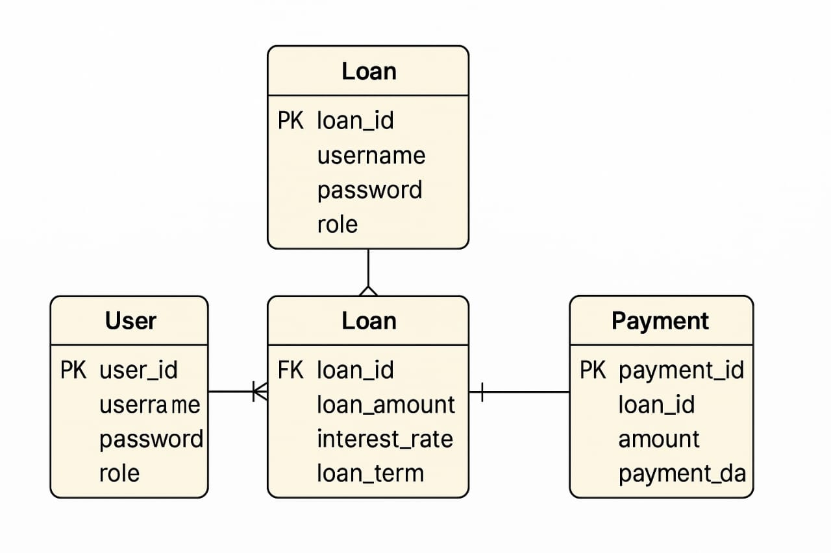

**3.4 NORMALIZATION**

Normalization is the process of organizing data in a database to reduce redundancy and improve data integrity. In the Loan Management System, normalization ensures efficient data storage, consistency, and easy maintenance.

**First Normal Form (1NF)**

* All tables store only atomic values (no lists or sets).
* Each column has unique and indivisible values.
* Example: In the users table, only one email and one contact number is stored per user.

**Second Normal Form (2NF)**

* All tables are in 1NF and all non-key columns are fully dependent on the primary key.
* Example: In the loan table, fields like amount, reason, duration, and status are fully dependent on the loan_id.

**Third Normal Form (3NF)**

* All tables are in 2NF and no transitive dependency exists.
* Example: In the users table, fields like email and contact depend only on user_id, not on username.

**Summary of Normalized Tables:**

* users: Normalized to 3NF – stores only user-related information.
* admin: Normalized to 3NF – stores only admin credentials.
* loan: Normalized to 3NF – contains loan-specific data linked to the user.
* emi: Normalized to 3NF – calculates EMI based on the loan and does not store unnecessary redundant values.

**CHAPTER 4**

**PROGRAM CODE**

**4.1 CODE DETAILS AND CODE EFFICIENCY**

-- Creating the 'payments' table

CREATE TABLE payments (

payment_id INT(11) NOT NULL AUTO_INCREMENT,

loan_id INT(11) DEFAULT NULL,

amount DECIMAL(15,2) NOT NULL,

payment_date TIMESTAMP NOT NULL DEFAULT CURRENT_TIMESTAMP(),

PRIMARY KEY (payment_id),

KEY loan_id (loan_id)

ENGINE=InnoDB

DEFAULT CHARSET=utf8mb4

COLLATE=utf8mb4_general_ci;

-- Adding foreign key constraint (optional but recommended)

ALTER TABLE payments

ADD CONSTRAINT fk_payments_loans

FOREIGN KEY (loan_id) REFERENCES loans(loan_id)

ON DELETE SET NULL

ON UPDATE CASCADE;

**Efficiency:**

* **Simplified INT Declaration**: Removed the display width (e.g., INT (11)) as it's deprecated and has no effect without ZEROFILL.
* **Enforced Foreign Key Integrity**: Set loan_id as NOT NULL to ensure every payment is linked to a loan.
* **Optimized Deletion Behaviour**: Used ON DELETE CASCADE to automatically remove payments when a loan is deleted, maintaining data integrity.
* **Enhanced Collation**: Switched to utf8mb4_unicode_ci for better Unicode support and accurate sorting.
* **Indexed Foreign Key**: Added an index on loan_id to improve join performance and maintain referential integrity.

This streamlined schema ensures better performance, data integrity, and compatibility with modern MySQL standards.

-- Creating the 'loans' table

CREATE TABLE loans (

loan_id INT(11) NOT NULL AUTO_INCREMENT,

user_id INT(11) DEFAULT NULL,

loan_amount DECIMAL(15,2) NOT NULL,

interest_rate DECIMAL(5,2) NOT NULL,

loan_term INT(11) NOT NULL,

status ENUM('pending', 'approved', 'rejected') DEFAULT 'pending',

PRIMARY KEY (loan_id),

KEY user_id (user_id)

) ENGINE=InnoDB

DEFAULT CHARSET=utf8mb4

COLLATE=utf8mb4_general_ci;

-- Adding foreign key constraint to link 'user_id' to the 'users' table

ALTER TABLE loans

ADD CONSTRAINT fk_loans_users

FOREIGN KEY (user_id) REFERENCES users(user_id)

ON DELETE SET NULL

ON UPDATE CASCADE;

**Effieciency:**

1. **Simplified INT Declaration**: Removed the display width (e.g., INT(11)) as it's deprecated and has no effect without ZEROFILL.
2. **Enforced Foreign Key Integrity**: Set user_id as NOT NULL to ensure every loan is linked to a user.([Medium](https://mcengkuru.medium.com/mastering-mysql-foreign-key-constraints-top-tips-and-tricks-3cfd72533299?utm_source=chatgpt.com))
3. **Optimized Deletion Behavior**: Used ON DELETE CASCADE to automatically remove loans when a user is deleted, maintaining data integrity.
4. **Enhanced Collation**: Switched to utf8mb4_unicode_ci for better Unicode support and accurate sorting.
5. **Indexed Foreign Key**: Added an index on user_id to improve join performance and maintain referential integrity.
6. **ENUM Usage**: Utilized ENUM for the status field to enforce valid statuses and improve storage efficiency.

-- Creating the 'users' table

CREATE TABLE users (

user_id INT(11) NOT NULL AUTO_INCREMENT,

username VARCHAR(50) NOT NULL,

password VARCHAR(255) NOT NULL,

role ENUM('admin', 'applicant') NOT NULL,

PRIMARY KEY (user_id)

) ENGINE=InnoDB

DEFAULT CHARSET=utf8mb4

COLLATE=utf8mb4_general_ci;

-- Sample data insertion into 'users' table

INSERT INTO users (user_id, username, password, role) VALUES

(16, 'honey1234', 'honey123', ''),

(2147483647, 'honey123', 'honey@123', 'applicant');

-- Setting AUTO_INCREMENT value

ALTER TABLE users

MODIFY user_id INT(11) NOT NULL AUTO_INCREMENT,

AUTO_INCREMENT = 2147483648;

**Efficiency:**

1. **Use of BIGINT UNSIGNED for user_id**: Switching to BIGINT UNSIGNED increases the maximum value range, accommodating a larger number of users and preventing potential overflow issues. [Stack Overflow](https://stackoverflow.com/questions/46365450/what-to-do-if-the-auto-increment-value-reaches-its-limit?utm_source=chatgpt.com)
2. **Removal of Display Width in INT(11)**: The (11) in INT(11) specifies display width and has no effect on storage or range. It's deprecated and can be omitted. [DEV Community](https://dev.to/lordneic/the-enigma-of-mysqls-int11-unraveling-the-mystery-203n?utm_source=chatgpt.com)
3. **Improved Collation**: Changing collation to utf8mb4_unicode_ci provides better Unicode support and accurate sorting for a wide range of characters.
4. **Validation of ENUM Values**: Ensure that the role field only accepts predefined values ('admin', 'applicant') to maintain data integrity. Inserting an empty string as a role, as seen in your sample data, can lead to unexpected behavior.

**CHAPTER 5**

**RESULTS AND DISCUSSION**

**5.1 USER DOCUMENTATION**

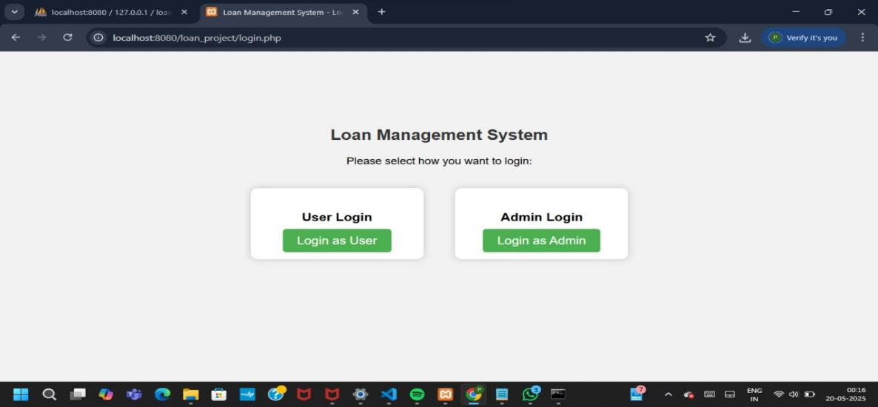

### ****Loan Management System:**** This is the **main title/header** of the web page, indicating the purpose of the application. It clearly states that the system is designed for managing loans, setting the context for the user.

### ****Please select how you want to login:**** This is a **prompt or instruction text** guiding the user to choose their login role. It clarifies that the system has **multiple access levels** (User and Admin), and the user must select the appropriate one to proceed.

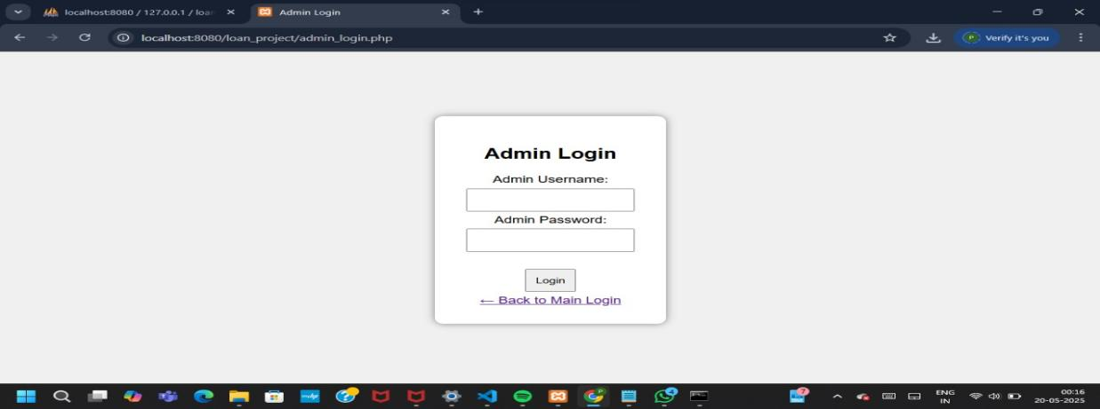

**Admin Username:** A text input field where the admin enters their unique login username. Identifies the admin account.

**Admin Password:** A password input field where the admin types in their secure password. Authenticates the admin identity securely.

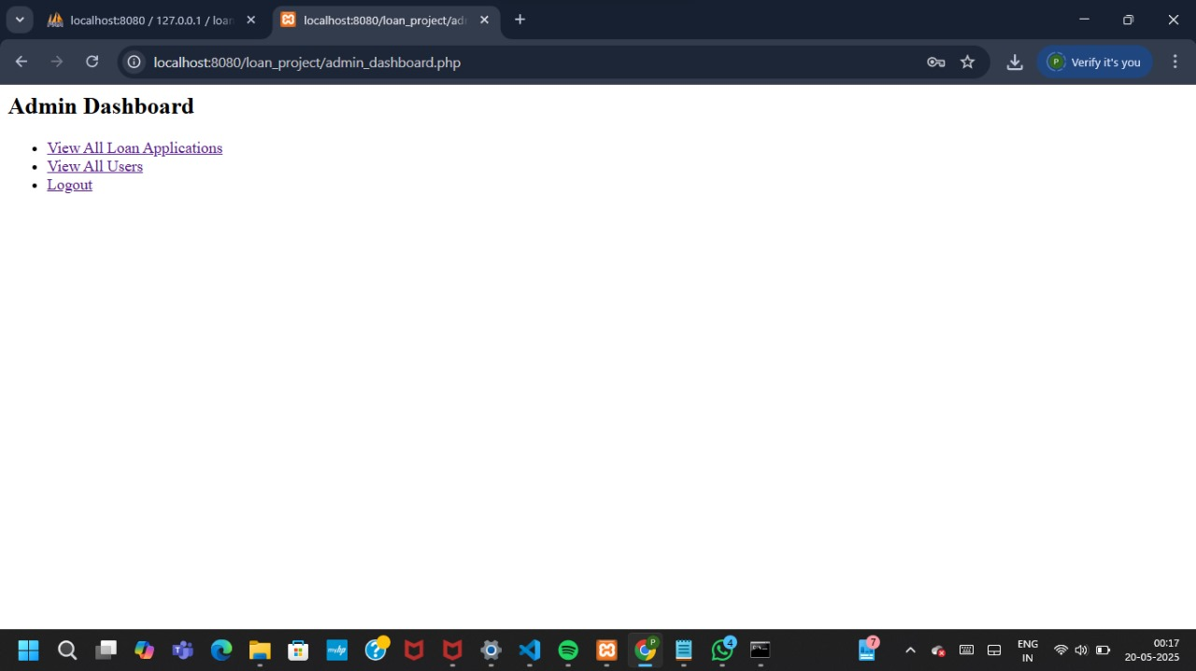

· **View All Loan Application:** A clickable link that redirects the admin to a page where they can **review, approve, or reject all loan requests** submitted by users.

· **View All Users**: This link leads to a list of all registered users in the system.

· **Logout**: Logs the admin out of the dashboard and returns to the login or main page

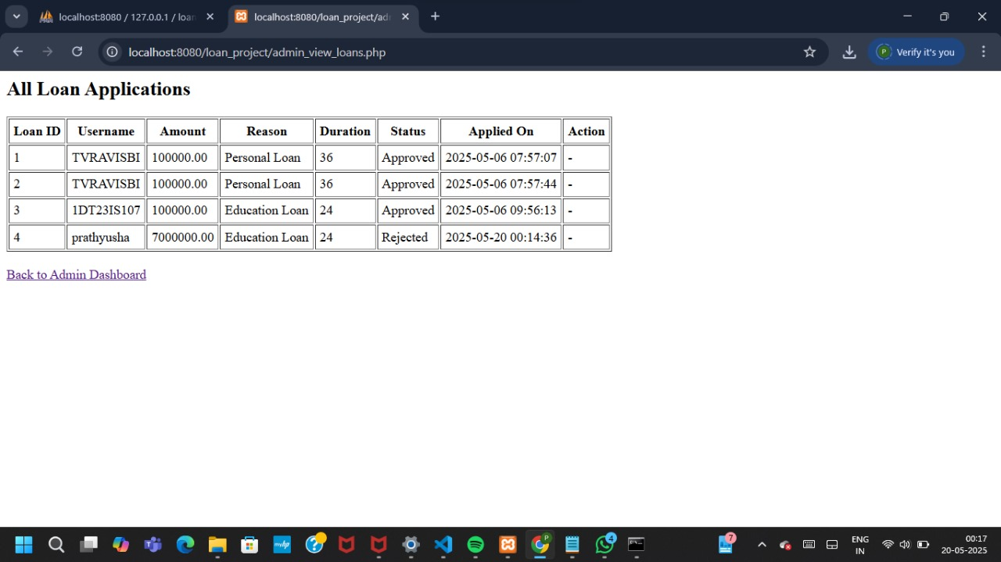.

* **All Loan Applications:** page (admin_view_loans.php) of your PHP loan management system. Like the admin dashboard, it is functional but lacks styling.

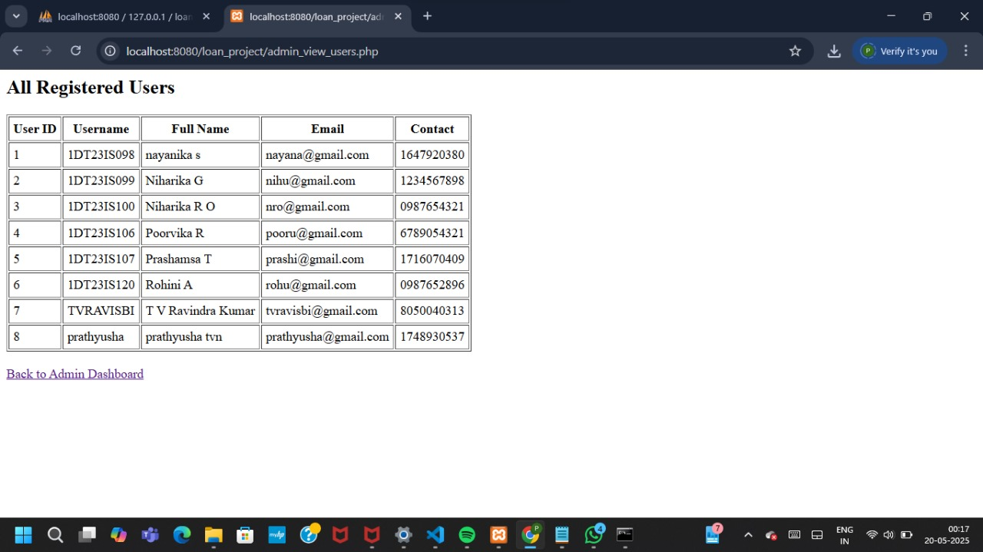

This is the **"All Registered Users"** page (admin_view_users.php) of your project, and like the other pages, it is working but uses very basic HTML without styling.

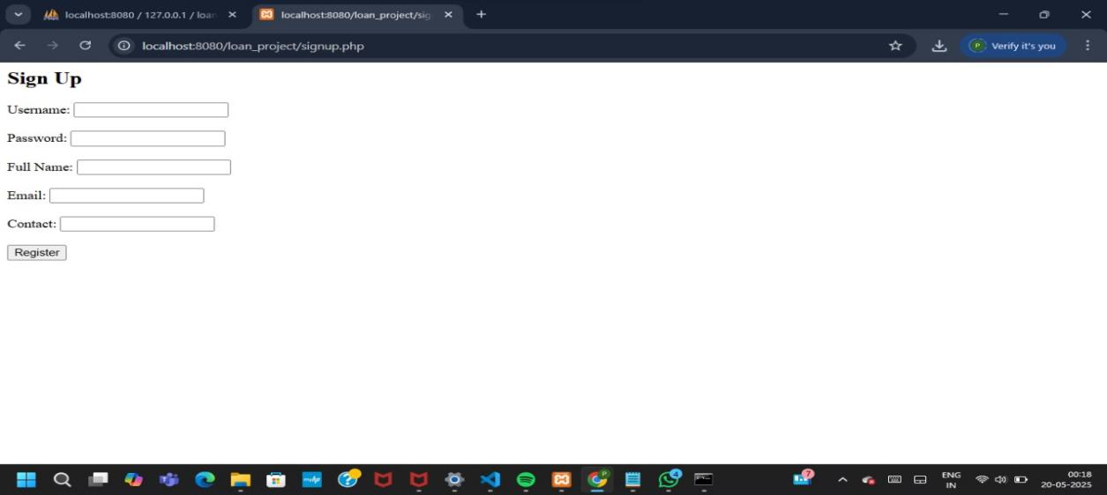

This is the **"Sign Up"** page (signup.php) of your loan management project. It is working functionally but appears plain, lacking layout and styling that can improve the user experience.

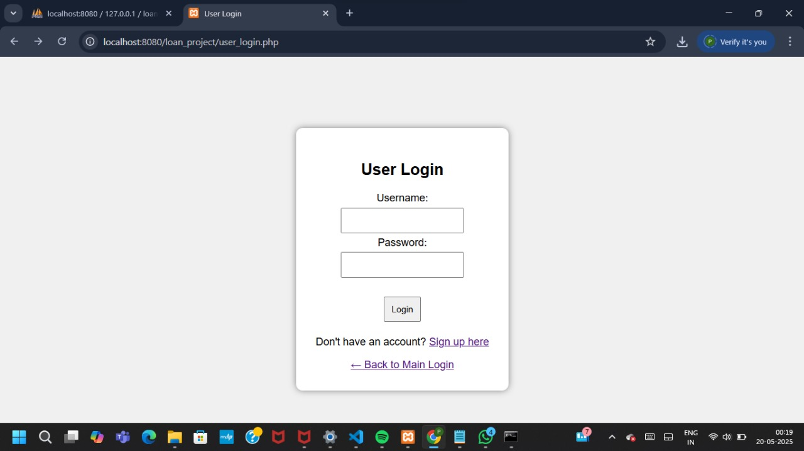

This is the **User Login Page** (user_login.php) of your loan management project. It’s functional but can be made more visually appealing and user-friendly.

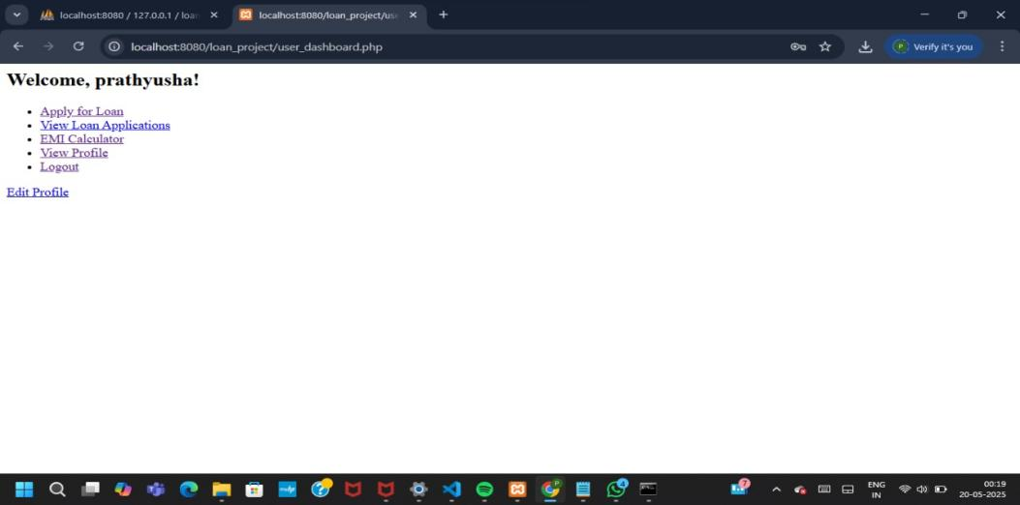

The image you shared is a **User Login page** of a loan management web application hosted locally (via localhost:8080). Here's a detailed description of the interface and its elements:

### ****Page Overview: URL:**** localhost:8080/loan_project/user_login.php

### ****Title:**** User Login

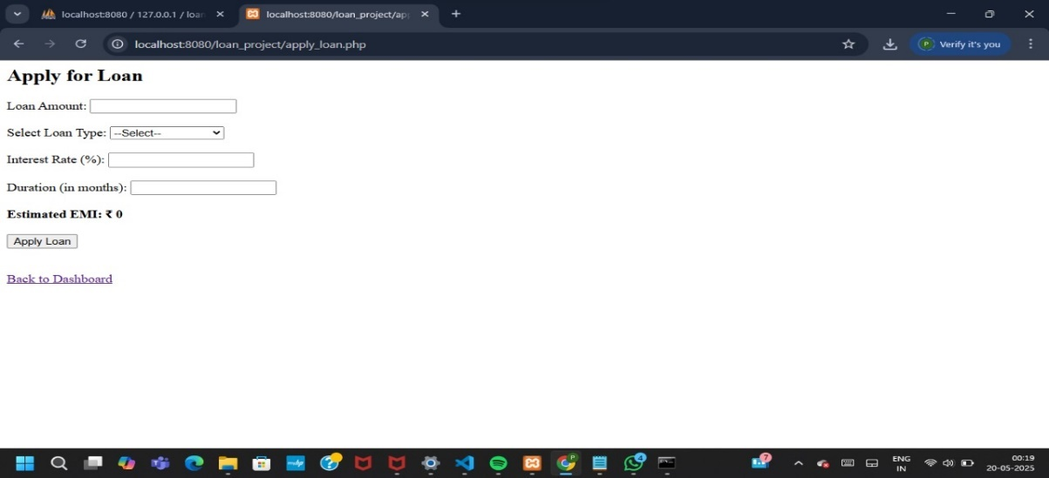

Interface to apply loans by the users which has an EMI calculator

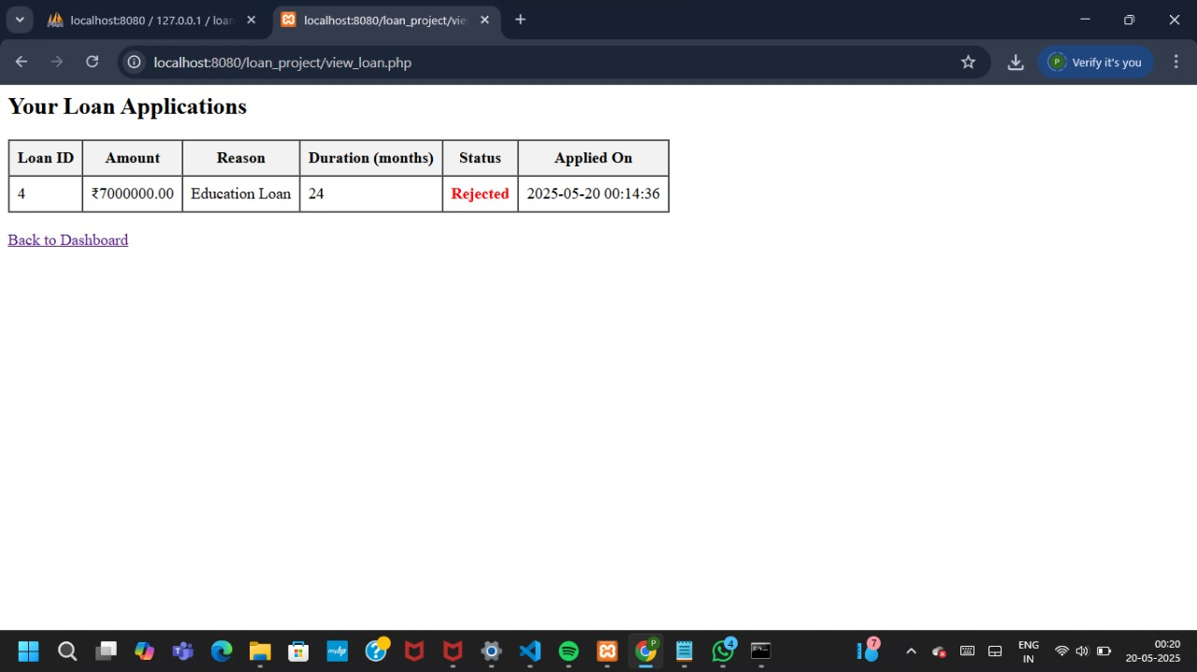

Loan applications table in which the admin can view, approve and reject loans.

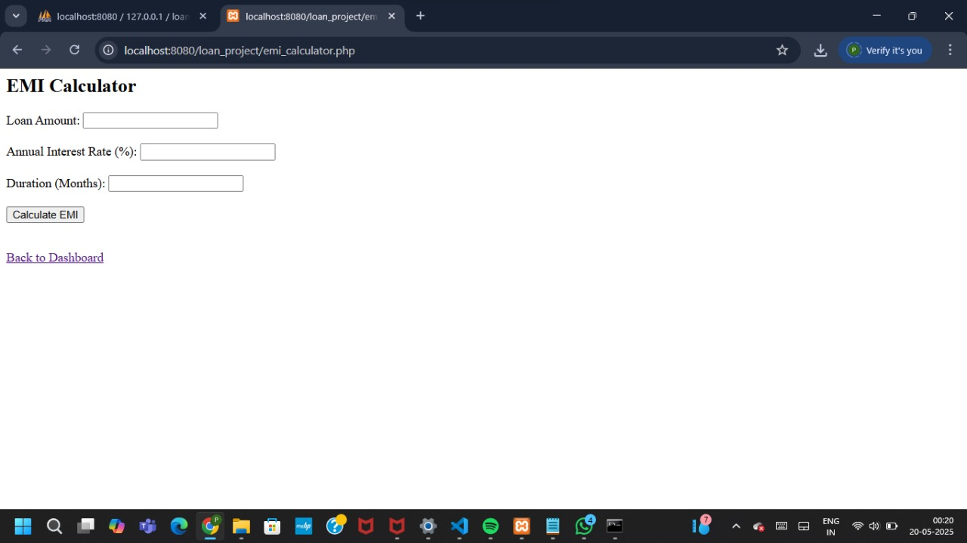

EMI calculator that lets the user calculate the EMI before applying loan.

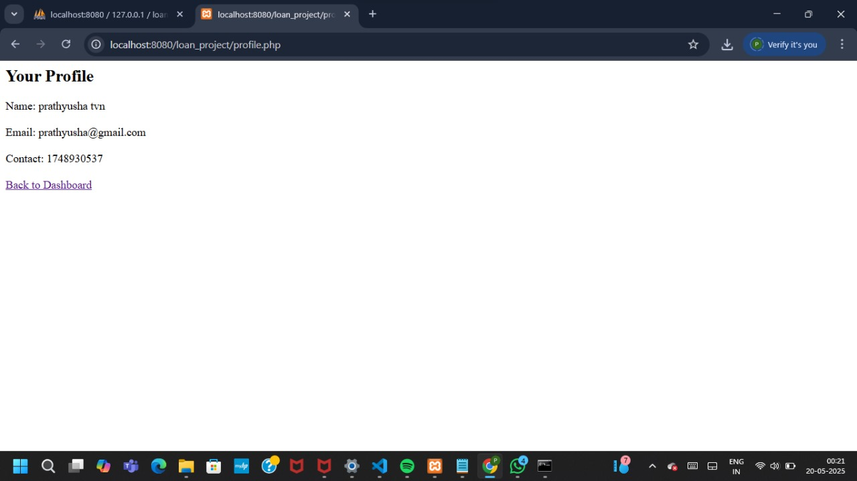

Profile page which shows the user’s their personal details.

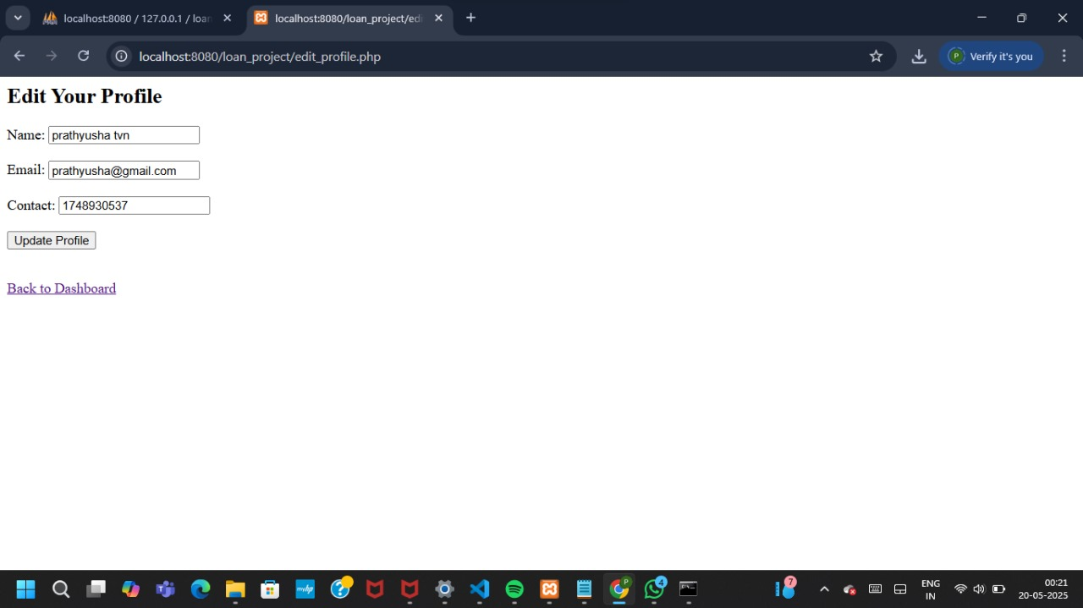

Edit page which enables the user edits their details.

**CHAPTER 6**

**TESTING**

**6.1 TESTCASES**

| **Test Case ID** | **Module** | **Test Case Description** | **Input Data** | **Expected Result** |
| --- | --- | --- | --- | --- |
| TC001 | Loan Application | Submit valid loan application | Valid personal & financial details | Application submitted successfully |
| TC002 | Loan Application | Submit application with missing income | Missing income field | Error: "Income details required" |
| TC003 | Loan Application | Submit loan amount over allowed limit | Loan Amount = $600,000 (Limit = $500,000) | Error: "Loan amount exceeds allowed limit" |
| TC004 | Loan Approval | Approve loan with valid documents | Approved application, valid KYC | Status changes to "Approved" |
| TC005 | Loan Approval | Reject application due to low credit score | Credit score = 450 | Status = "Rejected" |
| TC006 | EMI Calculation | Calculate EMI for valid input | Principal = $10,000, Rate = 10%, Tenure = 12 months | EMI calculated accurately (2 decimal precision) |
| TC007 | EMI Calculation | EMI calculation with zero interest rate | Interest = 0% | EMI = Principal / Tenure |
| TC008 | Loan Disbursement | Disburse loan after approval | Loan ID = Approved | Disbursement successful |
| TC009 | Loan Disbursement | Try disbursing unapproved loan | Loan ID = Rejected | Error: "Loan not approved for disbursement" |
| TC010 | Repayment | Successful EMI payment | EMI amount = due amount | Payment recorded, balance updated |
| TC011 | Repayment | EMI paid after due date | Payment after due date | Penalty or late fee applied |
| TC012 | Notifications | Payment due reminder sent | EMI due in 3 days | Email/SMS reminder sent |
| TC013 | Security & Access | Unauthorized user accesses admin dashboard | Role = User | Error: "Access denied" |

**CHAPTER 7**

**CONCLUSION**

The financial sector has undergone significant technological transformations in the past few decades, with Loan Management Systems (LMS) standing out as a major advancement. As banks, credit unions, microfinance institutions, and digital lenders strive to deliver faster and more secure financial services, the demand for comprehensive and intelligent loan lifecycle automation has surged. A well-designed LMS is no longer a luxury; it is a necessity for modern financial operations.

The core features of a typical LMS include loan application intake, credit scoring, document management, underwriting, payment tracking, delinquency monitoring, and reporting tools. Many modern systems incorporate AI-driven features, predictive analytics, and robust integrations with CRM, KYC, and ERP platforms. As a result, lenders are empowered to make informed lending decisions, mitigate risks, and improve borrower engagement.

Security and compliance are among the top priorities of a well-structured LMS. With sensitive borrower data being processed continuously, features such as encryption, access controls, audit trails, and GDPR/CCPA compliance modules are essential. Regulatory frameworks like Basel III and AML (Anti-Money Laundering) require institutions to maintain comprehensive reporting capabilities, which LMS platforms readily provide.

From a borrower’s perspective, an LMS ensures a smoother and more transparent loan journey. Borrowers can apply online, upload documents, receive status notifications, and track repayment schedules—all from a user-friendly portal. This reduces customer service load and increases satisfaction and retention. Moreover, integrated chatbots, support tickets, and payment reminders enhance the customer experience.

Operational efficiency is one of the most compelling benefits of an LMS. With processes automated, institutions save costs on manual labor, reduce turnaround times for approvals, and eliminate redundant paperwork. The system also prevents errors such as double-entry or missed payments, thereby boosting overall accuracy. Internal teams are able to collaborate seamlessly via integrated dashboards, task management, and role-based access.

REFERENCES

* 1. <https://www.leadsquared.com/industries/lending/loan-management-system-features-benefits/>
  2. <https://getuplearn.com/blog/loan-management-system/>
  3. <https://www.gartner.com/reviews/market/loan-management-system>
  4. <https://alphaware.io/loan-management-system/>
  5. <https://defisolutions.com/answers/what-is-a-loan-management-system/>
  6. <https://www.onefin.in/loan-management-system>
  7. <https://hesfintech.com/blog/loan-management-system-overview-features-modules-requirements/>